BrightTV Users-Viewers Case Study Visualization

This section is related to the visualization of the outcome of our analysis.
All the coding were done on Google Colab because of some issues I had on Databricks maybe related to my network which seems unstable.
The audiences were analyzed on number of users and viewers per category.
The outcome was similar on both considerations.
That is why we are presenting the visualizations per category on users(number) and viewers (Duration in seconds).
The users is based on number and the viewers is based on the duration per second.
The study has only covered the first 3 months of 2016 because most data covers that period.

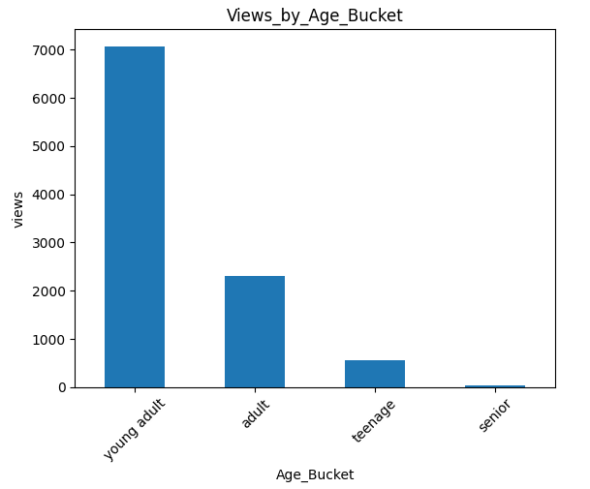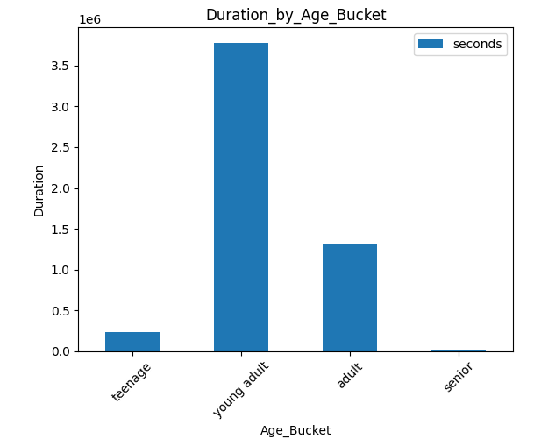

There are more users from young adults who also spend more time viewing than other buckets of age. My suggestion will be to find out which programs can also attract other categories of age while keeping the audience of young adults attracting more followers.
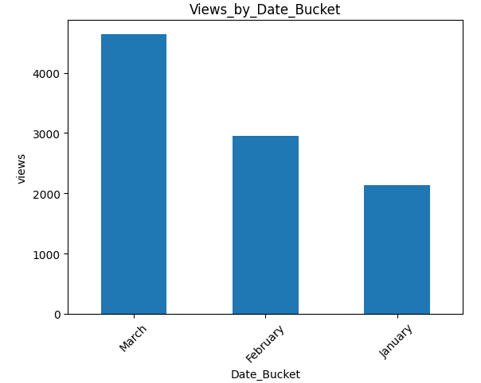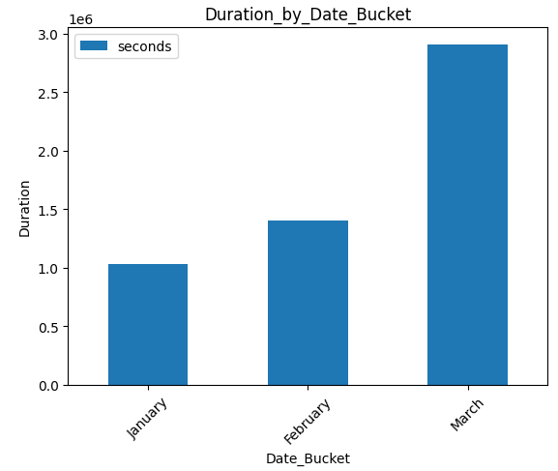

The audience shows that there have been more views with longer durations in March than in the first 2 months of the year. We should find out why this has been like that. It might be because of holidays of some programs that attract more attention from users. The commercial team should work toward creating programs which will increase the audience for the first 2 months.
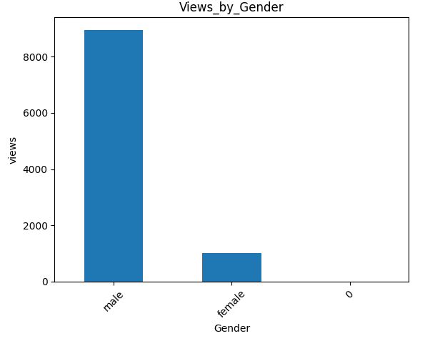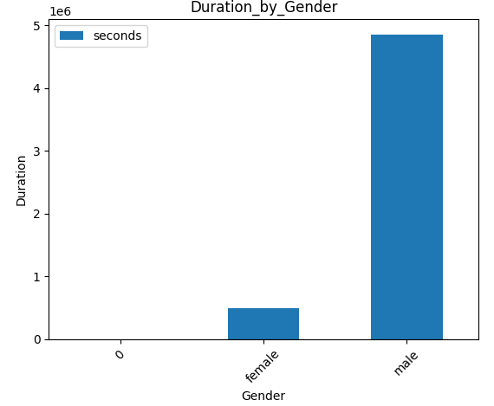

During the first 3 months, male users have provided the biggest audience. The commercial team should work toward attracting the female audience and innovate with programs that can interest this category of users. It might be series or movies.
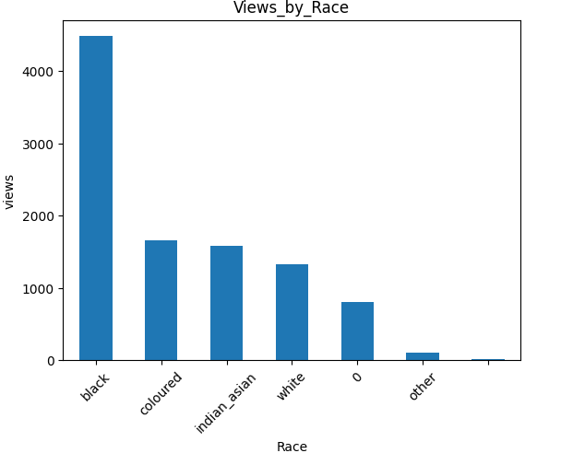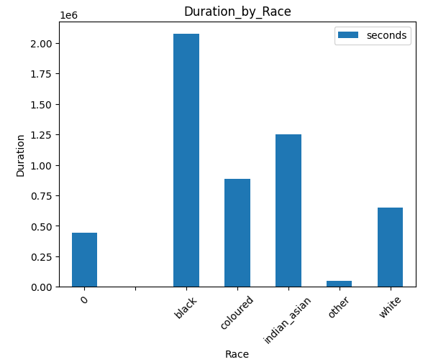

The Black audience has the most user. A work on understanding what could also attract other races to the programs provided by the channels or booklets. Diversity is a key factor to moving forward.
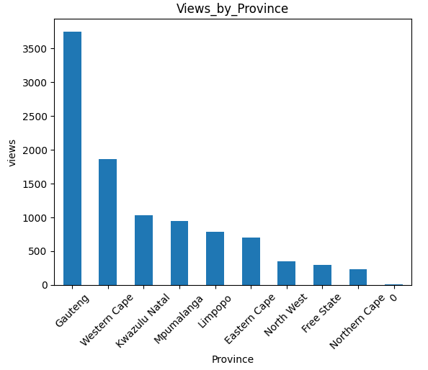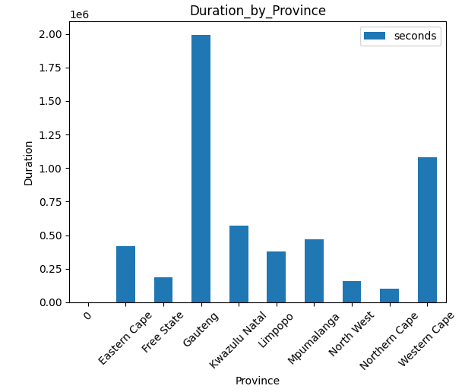

Gauteng is the province with more users than other provinces. This can be understood because that is the most populated with most infrastructures. There should increase the investments to provide quality programs and accessibility to the programs in the other provinces.
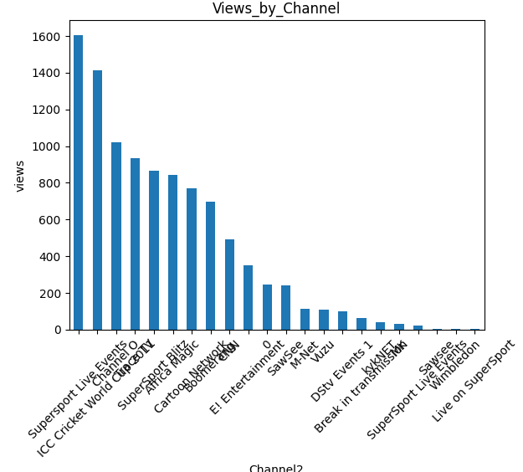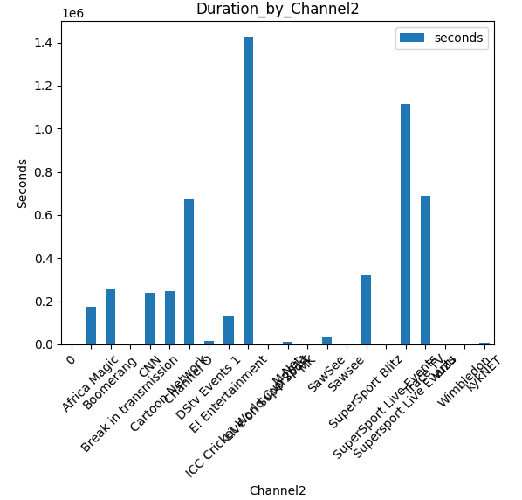

Sport channels have more audiences than others. Marketing department should promote channels that are lacking audiences, replace the unproductive channels by what people want to have.

